 **East West University**

(Department of Computer Science and Engineering)

**Project Report**

***Course Name****:*  Computer Networks

***Course Code****:* CSE 405

***Semester****:* Fall-2020

***Title:*** Design a full-fledged network for an organization with multiple subnets

***Submitted To:*** Dr. Anisur Rahman

Submitted By: Md. Ashrafur Rahman

Id: 2017-1-60-125  
Sec: 1  
Date: 08 January 2021

**Introduction**

**Background:**

International Apollo University, is an enterprise owns a large number of computers, with a complex network infrastructure. Apart from wired internet access to all the classrooms, labs, employee PCs, library and other administrative and academic wings, the university also provides wireless internet access for everyone. On top of that the university runs a number of complex networked systems to support several of its business process like admissions, advising, results, eTender, library management, accounts and so on. This complex network infrastructure is subnetted and switching/routing mechanisms are in practice.

As there perform lots of services, so huge number data is transmitting continuously. As there has a lots of service fast data transmission (Bandwidth), Reliability, Jitter everything needs to handle properly. Another thing is there working a lot of people and students, so data security is going to be concern.

**Method (Network Topology)**

As this is a Campus Area Network (CAN) & Concerning all these things, it may be best to use Mesh Topology. With different types of Lan network using a different type of IP address provides. All router follows **OSPF model** to find the shortest path to reach.

There has not only use wired connection but also **Wireless Access Poin**t to connect Mobile Phone and other wireless IoT devices.

Here all types of IP addresses are used- **A Class type, B Class type IP** and **C Class type IP** also.

**Limitations of this Topology**

As this Campus Area Network (CAN), So there has a few numbers of LAN. That’s why MESH is applicable. But if there is a very large number LAN, then Mesh doesn’t a proper network, Mesh will be an inappropriate connection. This is a predesign using Cisco Packet Tracer. To simulate the network.

**Design Details**

**Tools & Equipment**

1. Cisco Packet Tracer
2. 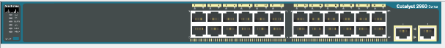 Switch 2960-24TT
3. 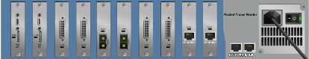Cisco PT Router
4. 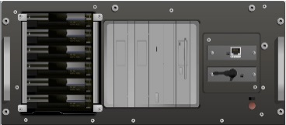Server
5. Packet Tracer Access Point
6. Straight Through Twisted Pair Cable and others

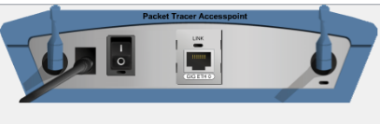

**Description**

To Connect multiple end devices, a switch has been used and connected by fast Ethernet Ports, all switches are connected Cisco PT Router and Added extra 6 PT-ROUTER-NM-1S serial Port. Because all routers are communicating via Serial Ports. Every LAN there has DHCP servers to Assign the IP Dynamically. The OSPF routing table is given in the last page.

Here, the first LAN is an administrative Network, Where all **Webserver (5.1.1.50) and DNS (5.1.1.200)** servers are incorporated. This Lan has a **A-class IP: 5.0.0.0**.

All devices are connected with a Switch and the switch is connected with a router. Router follow OSPF model incorporated with two Different A class IP network that are 10.0.0.0 & 20.0.0.0.

2nd LAN is a classroom and used a **Class ‘C’ type IP**: 192.168.20.0 to connect a few PC.

3rd LAN is a Library where Wireless Access Point is also available to the user who needs wireless network. This LAN connected with a router which is connected with **‘A’ class IP 30.0.0.0 and a ‘B’ class IP 140.0.0.0**

4th LAN is Lab1 is only some wired devices LAN- 192.168.40.0

5th LAN is LAB-2 192.168.50.0. there is some wired devices and Some **Wireless devices** to Connect Student personal Laptop wirelessly

6th Lan is office and Accounts Lan, where a **dedicated Printer is shared.** This printer can be used from the whole campus that is any of the CAN network is use this printer.

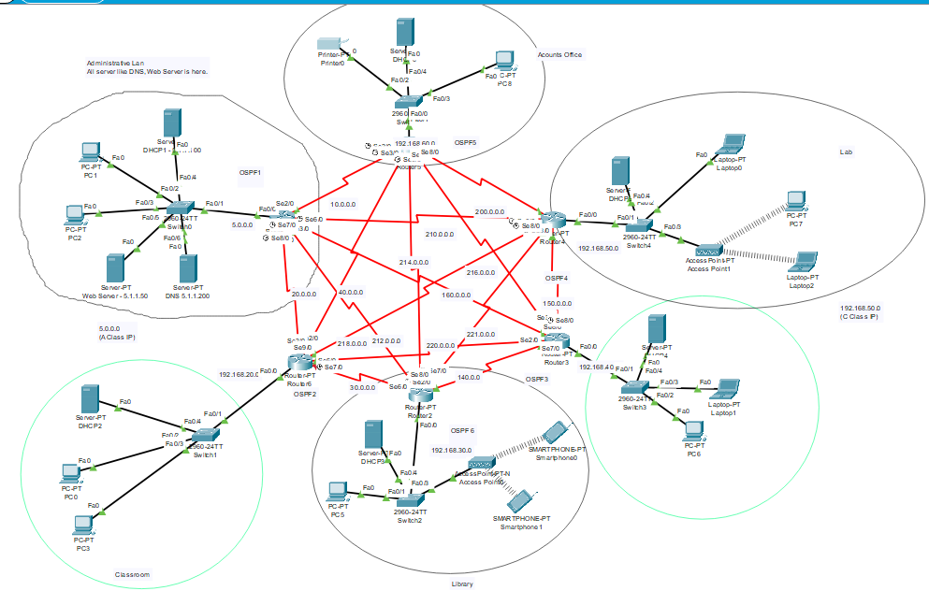

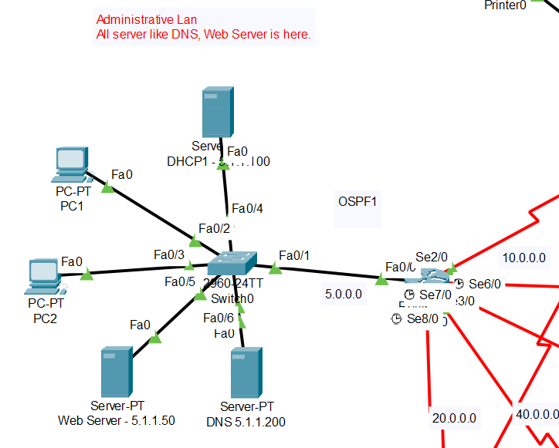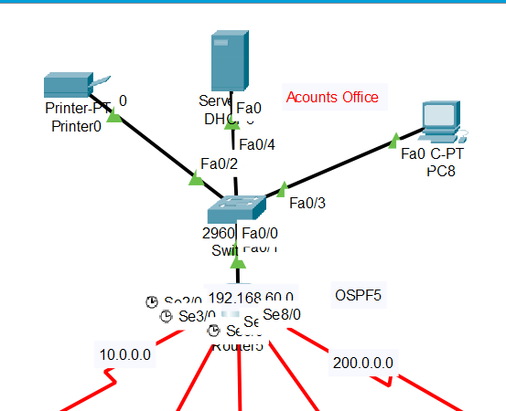

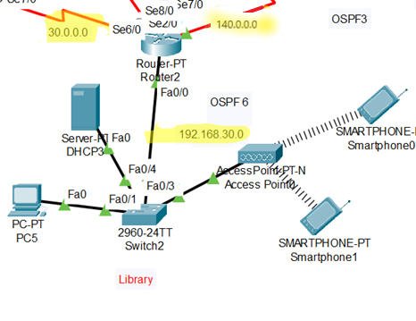

**Findings after Simulation:**

All the Networks are connected and can be ping easily. Website- [www.apollointernational.edu](http://www.apollointernational.edu) can be accessed from all networks. As all routers are connected using the OSPF routing table. So, data are transferred in the shortest possible path. This is because OSPF follows the Dijkstra Algorithm to find the shortest path. For the very time ping to another network is failled but browsing web server from any network is successful in first time. After web browsing all ping test is successful.  
Here we added some screenshot for better understandings.

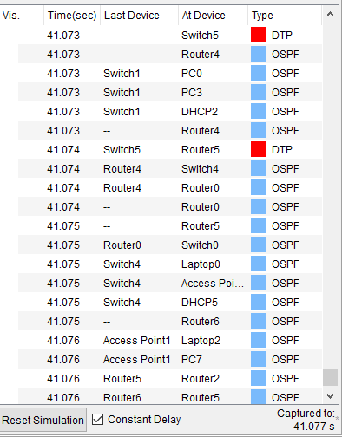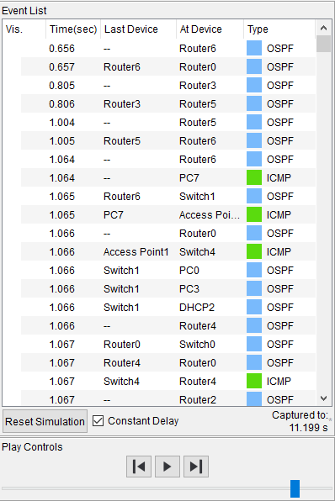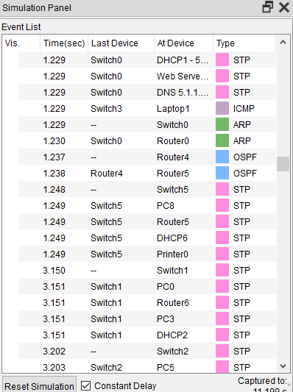

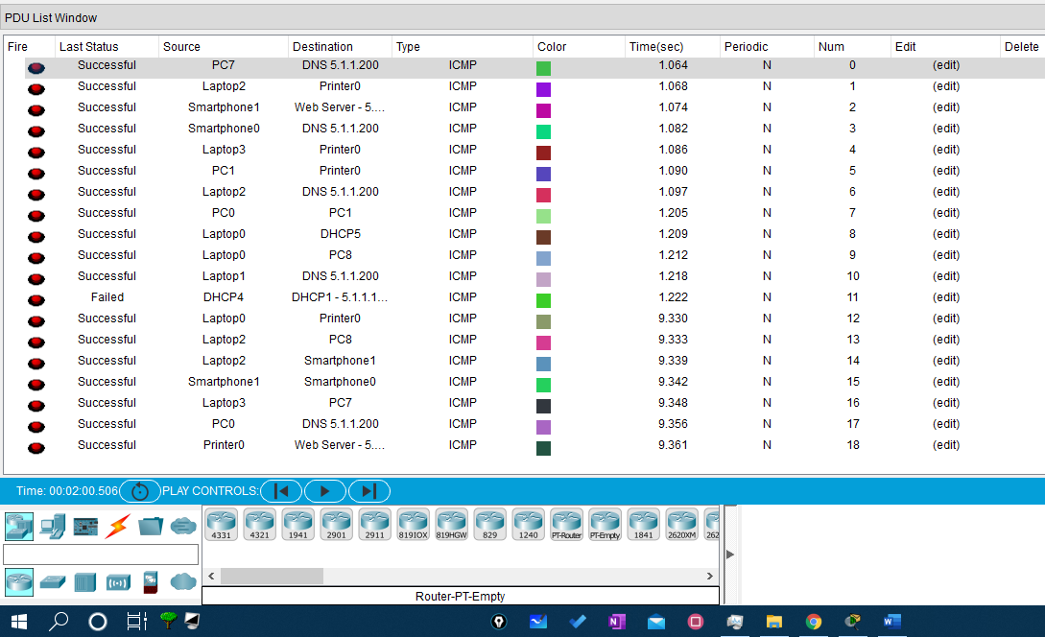

**Screenshots of PDU LIST window and Events Log after simulation**

**Conclusion:**

As a predesign purpose this is perfectly working. And No error is found when testing. Now its time to physically implement it to the campus. The CLI command of OSPF is given the following page.

**CLI Command of OSPF**

router ospf 1

network 5.0.0.0 0.255.255.255 area 1

network 10.0.0.0 0.255.255.255 area 1

network 20.0.0.0 0.255.255.255 area 1

network 160.0.0.0 0.0.255.255 area 1

network 210.0.0.0 0.0.0.255 area 1

network 212.0.0.0 0.0.0.255 area 1

router ospf 2

network 192.168.20.0 0.0.0.255 area 1

network 40.0.0.0 0.255.255.255 area 1

network 20.0.0.0 0.255.255.255 area 1

network 30.0.0.0 0.255.255.255 area 1

network 218.0.0.0 0.0.0.255 area 1

network 220.0.0.0 0.0.0.255 area 1

router ospf 3

network 140.0.0.0 0.0.255.255 area 1

network 150.0.0.0 0.0.255.255 area 1

network 160.0.0.0 0.0.255.255 area 1

network 192.168.40.0 0.0.0.255 area 1

network 216.0.0.0 0.0.0.255 area 1

network 216.0.0.0 0.0.0.255 area 1

network 2.0.0.0 0.0.0.255 area 1

router ospf 4

network 150.0.0.0 0.0.255.255 area 1

network 200.0.0.0 0.0.0.255 area 1

network 210.0.0.0 0.0.0.255 area 1

network 221.0.0.0 0.0.0.255 area 1

network 218.0.0.0 0.0.0.255 area 1

network 192.168.50.0 0.0.0.255 area 1

router ospf 5

network 192.168.60.0 0.0.0.255 area 1

network 40.0.0.0 0.255.255.255 area 1

network 10.0.0.0 0.255.255.255 area 1

network 200.0.0.0 0.0.0.255 area 1

network 214.0.0.0 0.0.0.255 area 1

network 216.0.0.0 0.0.0.255 area 1

router ospf 6

network 140.0.0.0 0.0.255.255 area 1

network 192.168.30.0 0.0.0.255 area 1

network 30.0.0.0 0.255.255.255 area 1

network 212.0.0.0 0.0.0.255 area 1

network 214.0.0.0 0.0.0.255 area 1

network 221.0.0.0 0.0.0.255 area 1